Question : 1
Install Seaborn in your Python environment and use it to create a histplot showing the distribution of delivery times (in minutes) for 50 Zomato food orders. Generate random data if needed :
pip install seaborn
import seaborn as sns
import matplotlib.pyplot as plt
import numpy as np
np.random.seed(42)
delivery_times =np.random.randint(20,61,50)
sns.histplot(delivery_times, bins=8, kde=True)
plt.title("Zomato Delivery Time Distribution")
plt.xlabel("Delivery Time (Minutes)")
plt.ylabel("Number of Orders")
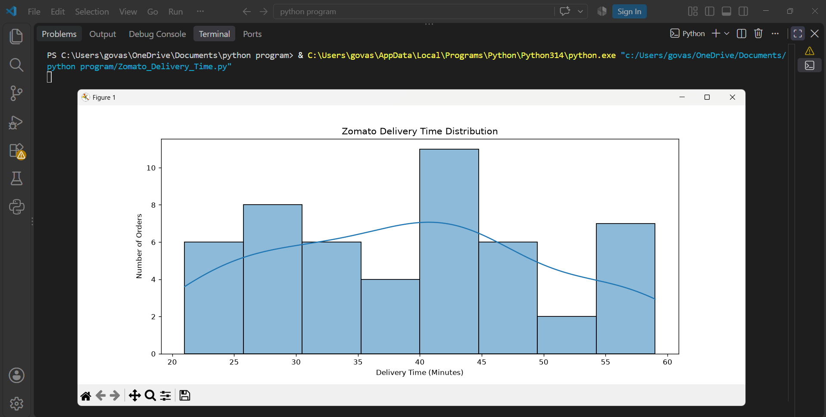
plt.show()
Question : 2
Load the 'tips' dataset from Seaborn and create a boxplot to visualize the distribution of total bill amounts by day of the week, similar to how Zomato might analyze spending patterns across weekdays :

import seaborn as sns
import matplotlib.pyplot as plt

tips =sns.load_dataset("tips")
sns.boxplot(data=tips,x="day",y="total_bill")
plt.title("Total Bill Amount by Day")
plt.xlabel("Day of the Week")
plt.ylabel("Total Bill Amount")
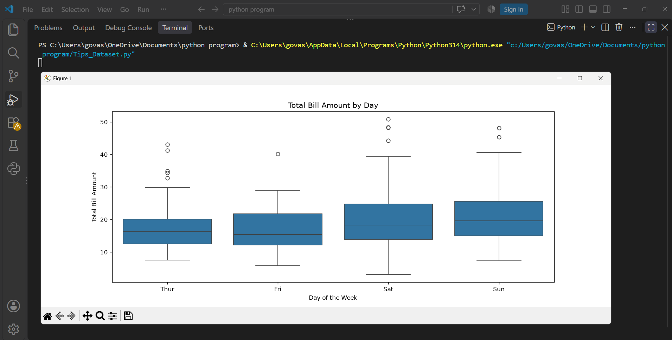
plt.show()
Question : 3
Simulate IPL match scores for 8 teams and use a violinplot to compare the run distributions per team. Style your plot using the 'darkgrid' Seaborn theme :

import seaborn as sns
import matplotlib.pyplot as plt
import pandas as pd
import numpy as np

sns.set_theme(style="darkgrid")
np.random.seed(42)
teams =[
"CSK","MI","RCB","KKR",
"GT","RR","SRH","DC"]
data = []
for team in teams:
scores =np.random.randint(120,221,30)
for score in scores:
data.append([team,score])
df =pd.DataFrame(data, columns=["Team","Runs"])

sns.violinplot(data=df, x="Team", y="Runs")
plt.title("IPL Run Distribution by Team")
plt.xlabel("Team")
plt.ylabel("Runs")
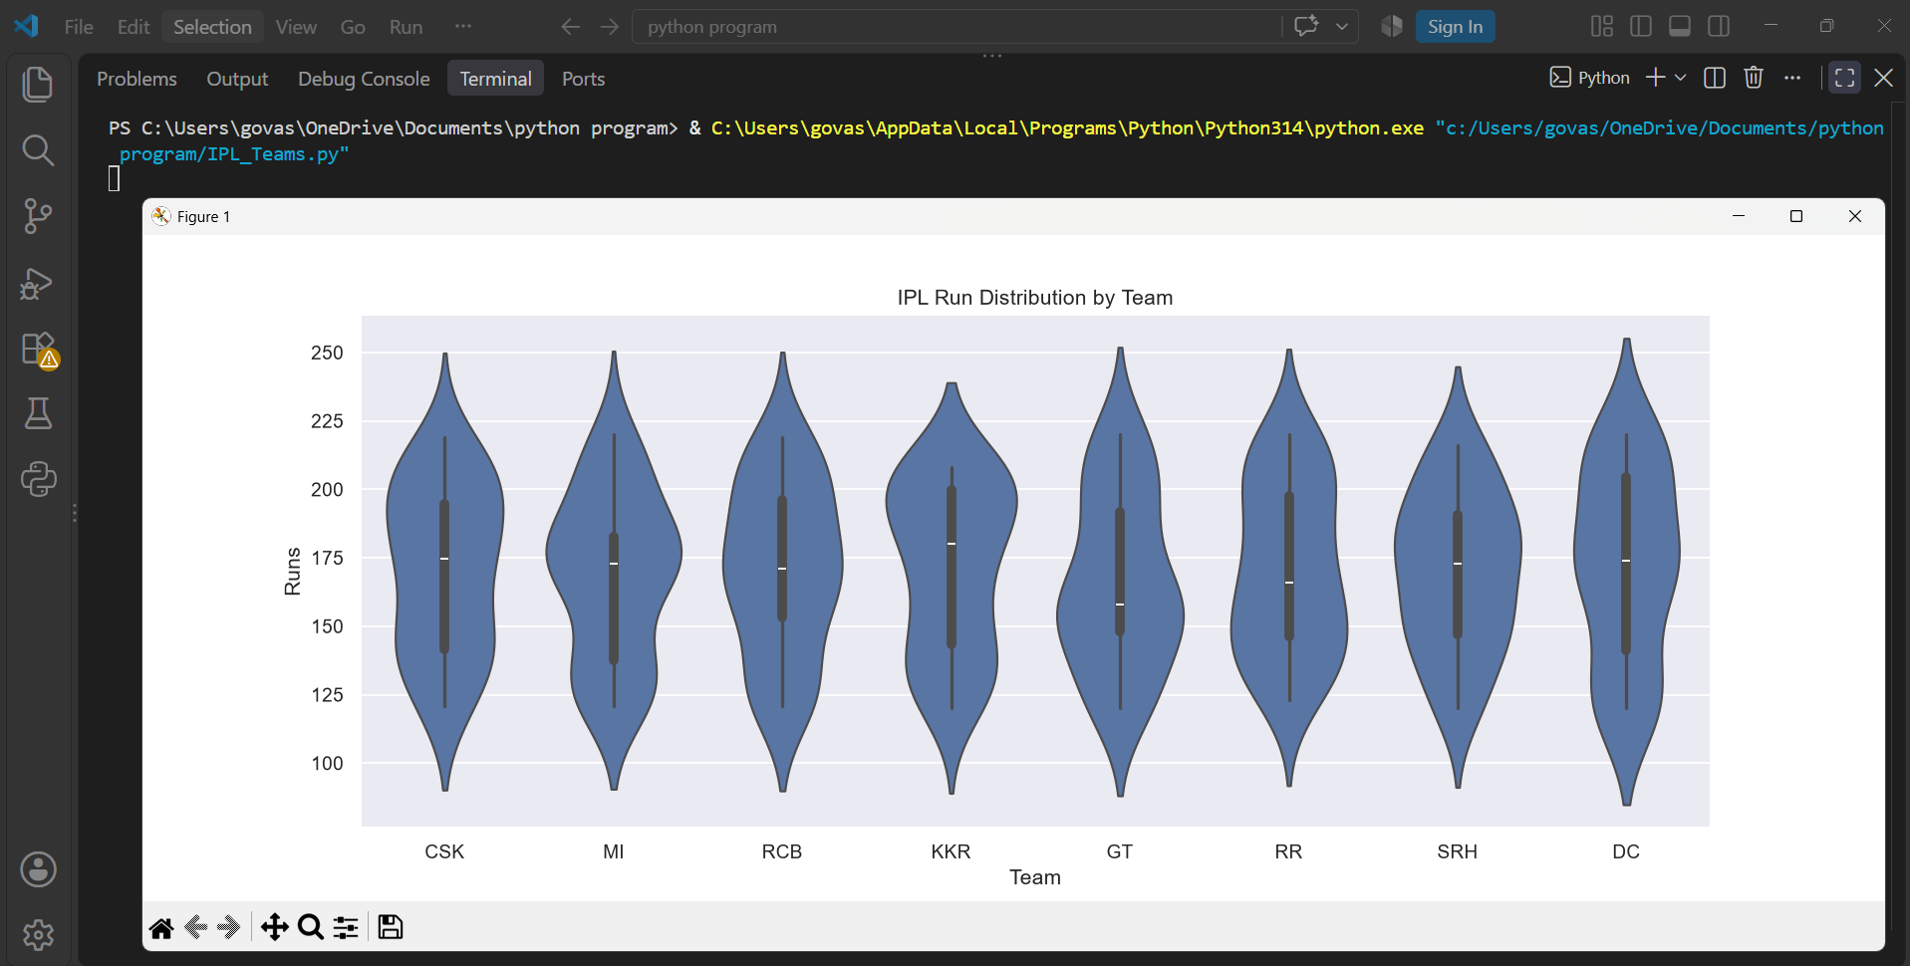
plt.show()

Question : 4
Create a countplot that displays the number of songs per genre from a list of 40 Spotify tracks, with at least 4 different genres represented.<br><br><em><strong>Hint:</strong> Use a Python list or pandas DataFrame to store your data, then plot with Seaborn : </em>

import seaborn as sns
import matplotlib.pyplot as plt
import pandas as pd

genres =[ "Pop", "Rock", "Hip-Hop", "Pop", "Jazz",
"Rock", "Pop", "Hip-Hop", "Jazz", "Pop",
"Rock", "Pop", "Hip-Hop", "Jazz", "Rock",
"Pop", "Hip-Hop", "Pop", "Rock", "Jazz",
"Pop", "Rock", "Hip-Hop", "Pop", "Jazz",
"Rock", "Pop", "Hip-Hop", "Jazz", "Pop",
"Rock", "Pop", "Hip-Hop", "Jazz", "Rock",
"Pop", "Hip-Hop", "Pop", "Rock", "Jazz"]
df =pd.DataFrame({"Genre": genres})
sns.countplot(data=df, x="Genre")
plt.title("Number of Spotify Songs by Genre")
plt.xlabel("Genre")
plt.ylabel("Number of Songs")
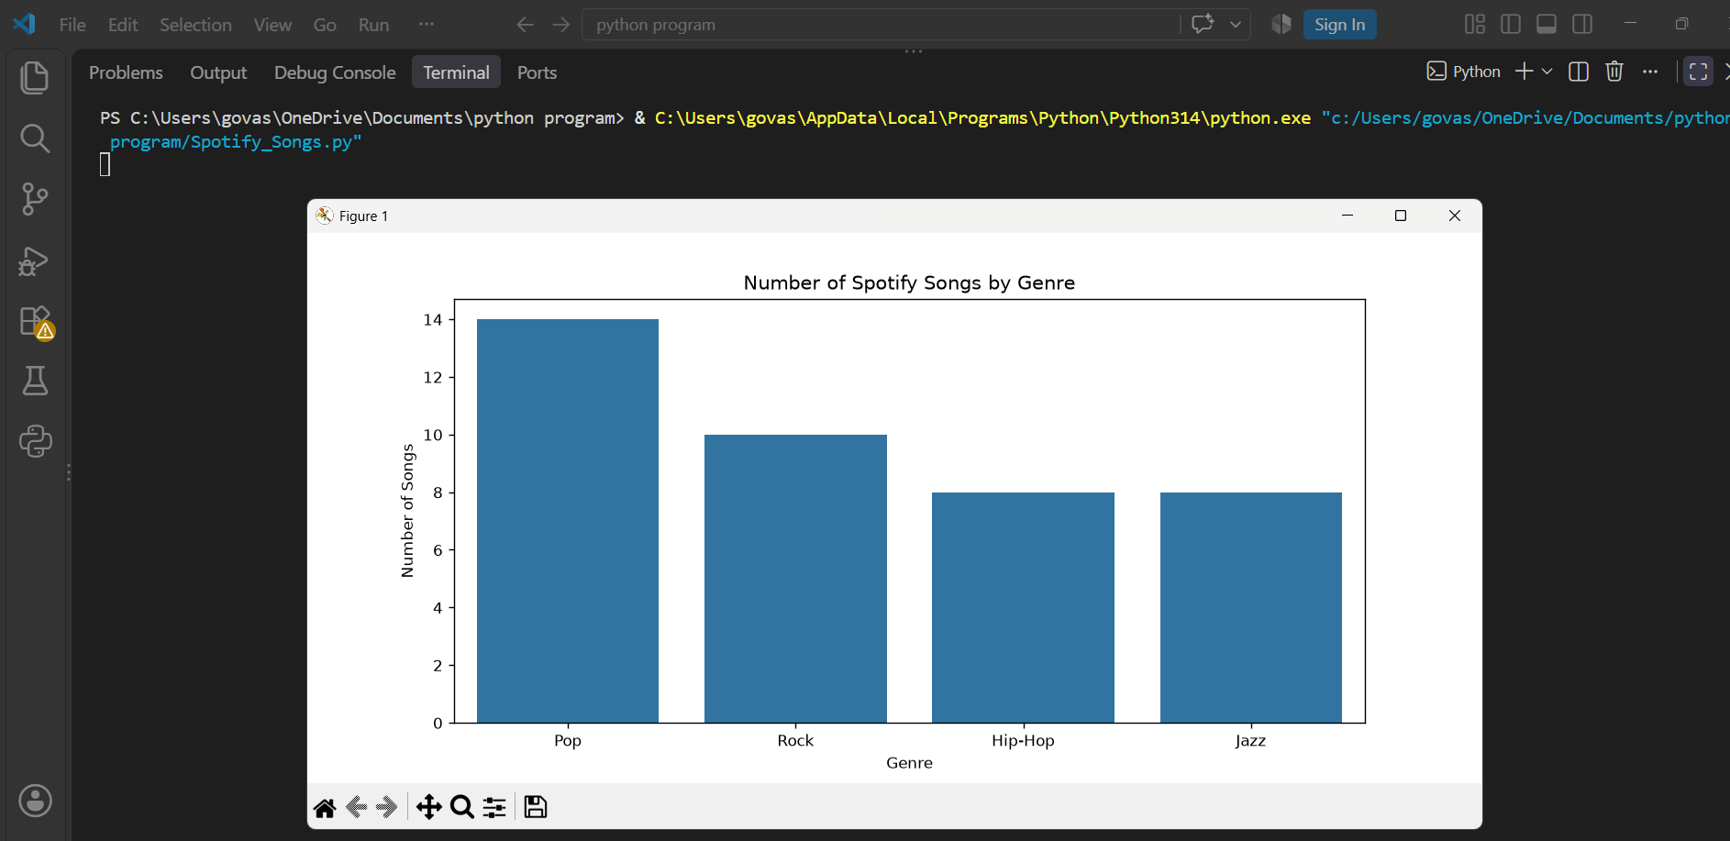
plt.show()
Question : 5
Use Seaborn's kdeplot to visualize the distribution of daily step counts for a week, as if analyzing data from a fitness app. Apply the 'whitegrid' theme and customize the plot color :

import seaborn as sns
import matplotlib.pyplot as plt
sns.set_theme(style="whitegrid")
steps =[4500,6200,7100,5800,8500,9200,7600]
sns.kdeplot(steps, fill=True, color="green")
plt.title("Daily Step Count Distribution")
plt.xlabel("Number of Steps")
plt.ylabel("Density")
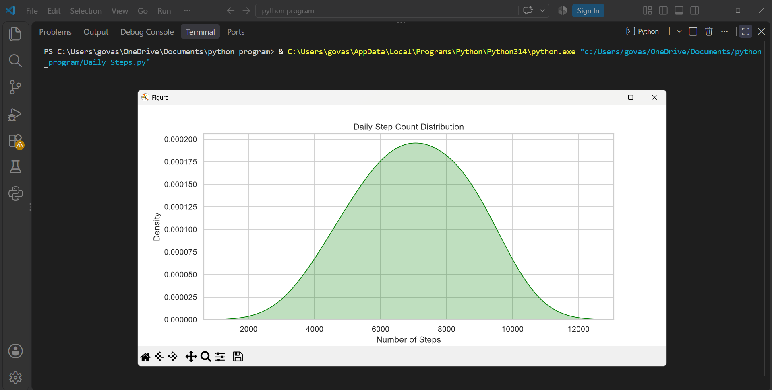
plt.show()

